

lab 4



NAME = AKHTAR ALI

ID = 34241

Submitted to MAM NABEELA KAUSAR

October 20, 2022

* Bubble sort :

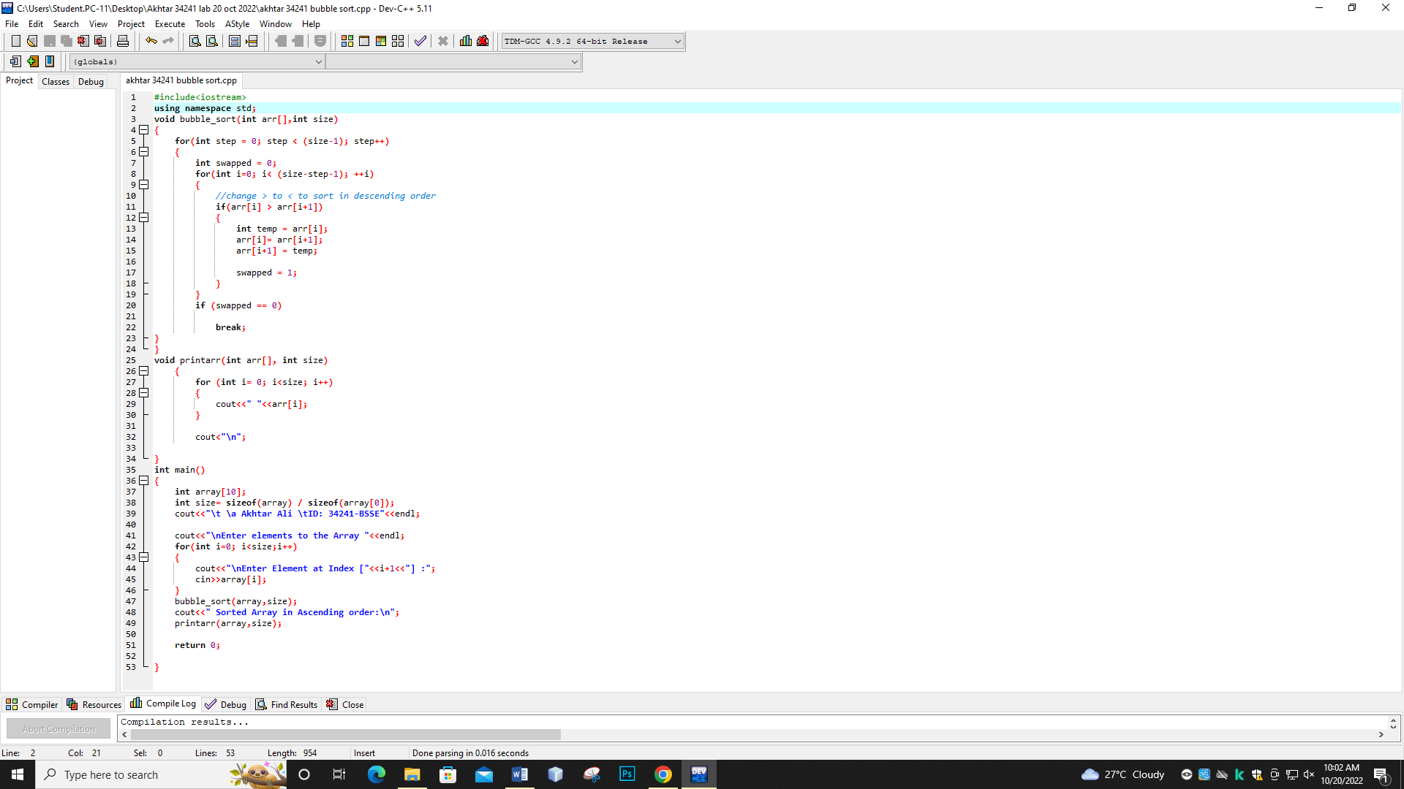

OUTPUT :

